3rd International Social Prescribing Network Conference
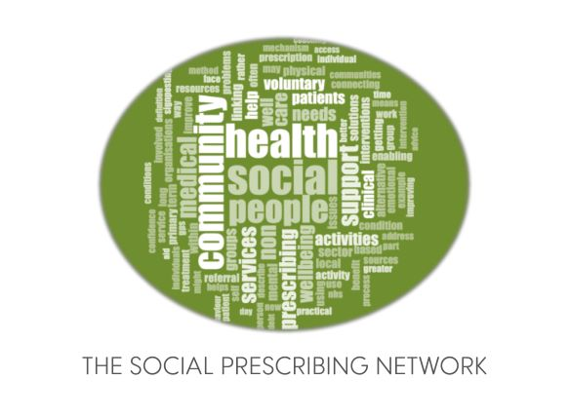
Social prescribing and community - beyond the pandemic
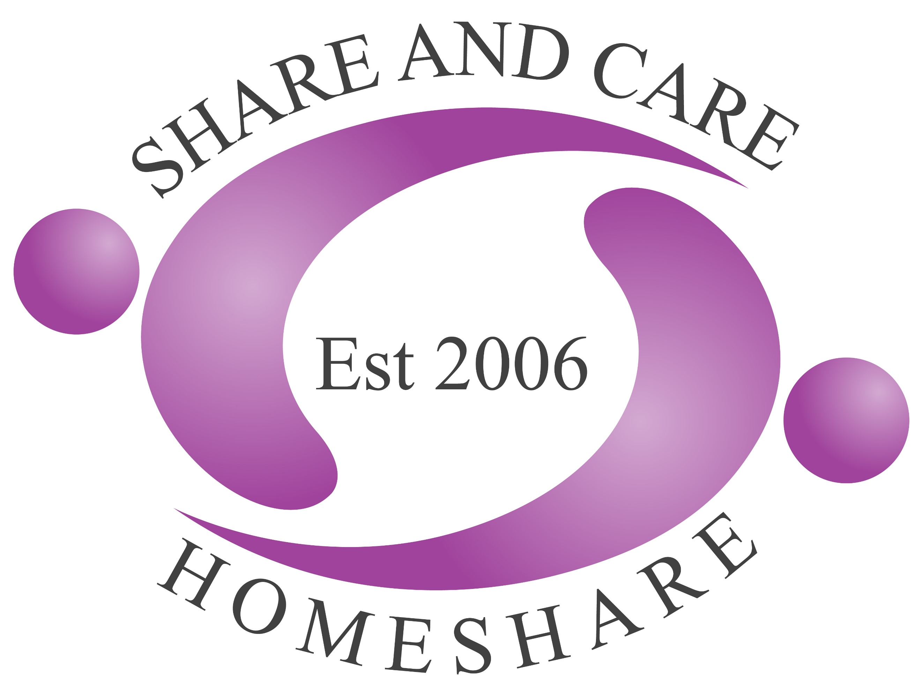
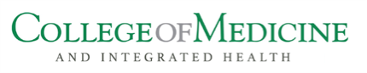
4th- 5th March 2021, Online, GMT +1.

ABSTRACT SUBMISSION GUIDANCE

Who should attend this conference?
The conference is aimed at anyone, from anywhere in the world who has a role in social prescribing or is interested in developing social prescribing - from providers of social prescribing activities and service users and their communities, through to the commissioners of services and everyone in between. The content is provided to facilitate collaboration and learning from colleagues in other social prescribing roles and sectors. The conference is international and delegates from all countries around the world are welcomed and encouraged to attend or submit research abstracts.

Topics for consideration
On both days we will be hosting concurrent sessions for research presentations.
We are inviting abstracts to be submitted on research that you are doing in relation to social prescribing.

This year the research committee is particularly interested in research relating to social prescribing for inequalities and wider determinants of health but are open to research in all areas of social prescribing being submitted for consideration.

Information to note before submitting your abstract
- We usually have more abstract submissions that we have slots for oral presentations, and some people will be offered the opportunity to create a poster for our virtual poster hall, instead of an oral presentation.
- Oral presentation slots will be 10 minutes in length.
- Virtual posters will be created in PDF format and will be accompanied by a 2 minute video explanation.
- Submit your abstract to spnc@salford.ac.uk no later than Wednesday December 2th 2020.
- Late submissions will not be accepted.
- We aim to notify you in early January 2021 if your abstract has been successful.
- Please ensure that permission to present the data has been put in place before submitting your abstract and that all data sharing adheres to General Data Protection Regulations and the Data Protection Act (2018)
- If your abstract is selected, you will be expected to book a ticket for the conference, so please ensure you can attend before submitting your abstract. Please use this link to book your tickets. For all further information and queries please email spnc@salford.co.uk

Submission process
We invite you to submit an abstract no longer than 300 words providing the following information and adhering to the headings below:
Title or project/ research:
Do you have permission to present this data? (Yes/No)
Name(s) of people in the research/ project team and name of organisation:
Name and email address of person who will present research if abstract is selected
Aim of project/research:
Method(s) used:
Key Findings/Learning:
Conclusions:

Once all abstracts have been received, we will peer review them for quality and best fit for the conference programme and then create specific categories for the concurrent research presentation sessions.

For all further information and queries please email spnc@salford.co.uk

