3rd International Social Prescribing Network Conference
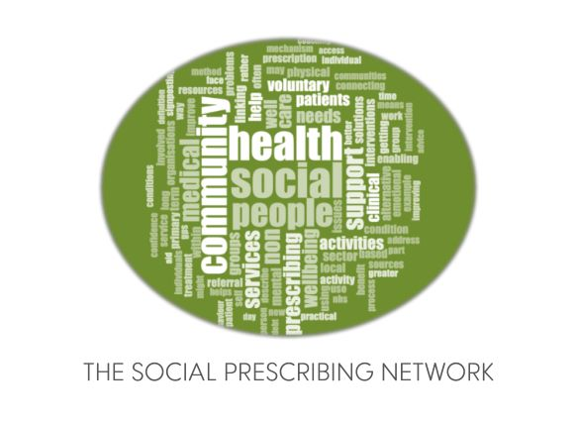
Social prescribing and community - beyond the pandemic
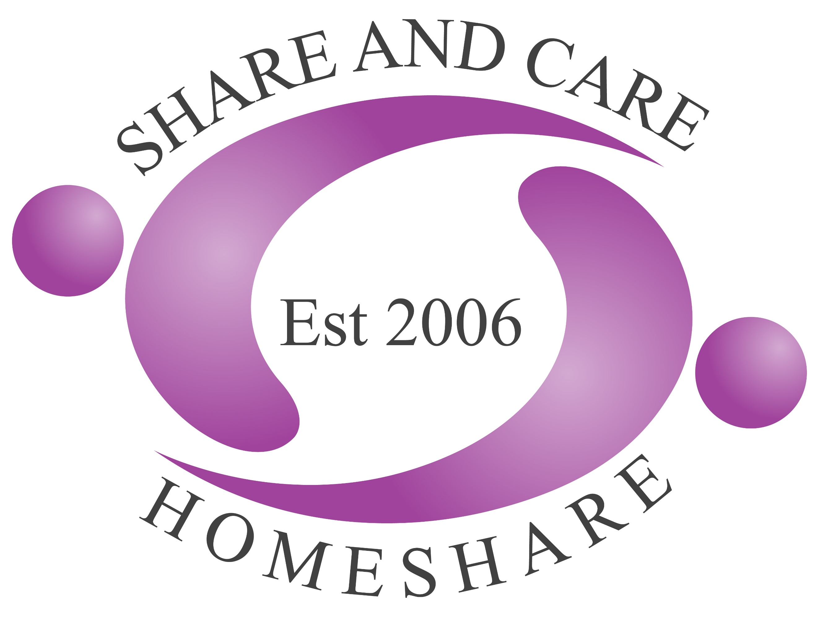
4th- 5th March 2021, Online, GMT +1.

CALL FOR ABSTRACTS

About the conference
This is the 3rd international event for our Social Prescribing Network and is the only international conference for social prescribing in the world. The Social Prescribing Network Steering Committee have decided to use this conference to shine a light on the role of community in social prescribing and to reflect on the role of social prescribing throughout and beyond the Covid-19 pandemic. We will explore what ‘great’ social prescribing looks like and how social prescribing is addressing the wider determinants of health and inequalities. Social prescribing has been spreading around the world and we look forward to hearing from and sharing with people from a range of countries. This event will run over two days and will be held online, with every effort made to maintain opportunities for networking. We will also have some satellite events around the main conference.

What topics will be covered at the conference?
We are creating our online programme at the moment and will release more detail in due course. Examples of keynote speakers and themed sessions are below.

Confirmed Keynote Speaker Day 1: Andy Burnham, Mayor of Greater Manchester
Confirmed Keynote Speaker Day 2: Dr Kate Mulligan, Assistant Professor, Dalla Lana School of Public Health, University of Toronto. Winner of the Best International Social Prescribing Scheme 2018.

Our concurrent workshop will cover the following areas
- Social prescribing that supports community development
- Culture, Arts and Health in Social prescribing
- Social Prescribing for people Not in Employment, Education or Training
- Seed and the Community – the role of green prescribing
- Social prescribing for Carers
- The role of Digital in Social Prescribing
- Social Prescribing for Early Years, Children and Young People.
- How does social prescribing support the housing sector and the homeless?

Who should attend this conference?
The conference is aimed at anyone, from anywhere in the world who has a role in social prescribing or is interested in developing social prescribing - from providers of social prescribing activities and service users and their communities, through to the commissioners of services and everyone in between. The content is provided to facilitate collaboration and learning from colleagues in other social prescribing roles and sectors. The conference is international and delegates from all countries around the world are welcomed and encouraged to attend or submit research abstracts.

Abstract submission information
On both days we will be hosting concurrent sessions for research presentations. We are inviting abstracts to be submitted on research that you are doing in relation to social prescribing. We have not set specific categories due to the wide reach of social prescribing. This year, however, the research committee is particularly interested in research relating to social prescribing for inequalities and wider determinants of health.

Once all abstracts have been received, we will peer review them for quality and best fit for the conference programme and then create specific categories for the concurrent research presentation sessions. We usually have more abstract submissions that we have slots for oral presentations, and some people will be offered the opportunity to create a poster for our virtual poster hall, instead of an oral presentation.

We invite you to submit an abstract no longer than 300 words providing the following information and adhering to the headings below:
Title:
Name and organisation:
Aim of project/research:
Method(s) used:
Key Findings/Learning:
Conclusions:
Submit your abstract to spnc@salford.ac.uk no later than December 4th 2021. NB late submissions will not be accepted.
Please ensure that permission to present the data has been put in place before submitting your abstract and that all data sharing adheres to General Data Protection Regulations and the Data Protection Act (2018)
If your abstract is selected, you will be expected to book a ticket for the conference, so please ensure you can attend before submitting your abstract. Please use this link to book your tickets. For all further information and queries please email spnc@salford.co.uk

